Week-05-Nested Loops-While and for Jumps in Loops

Week-05-01-practice session -coding

Reg no:24101289

Name :Tamilselvan.k

Q1

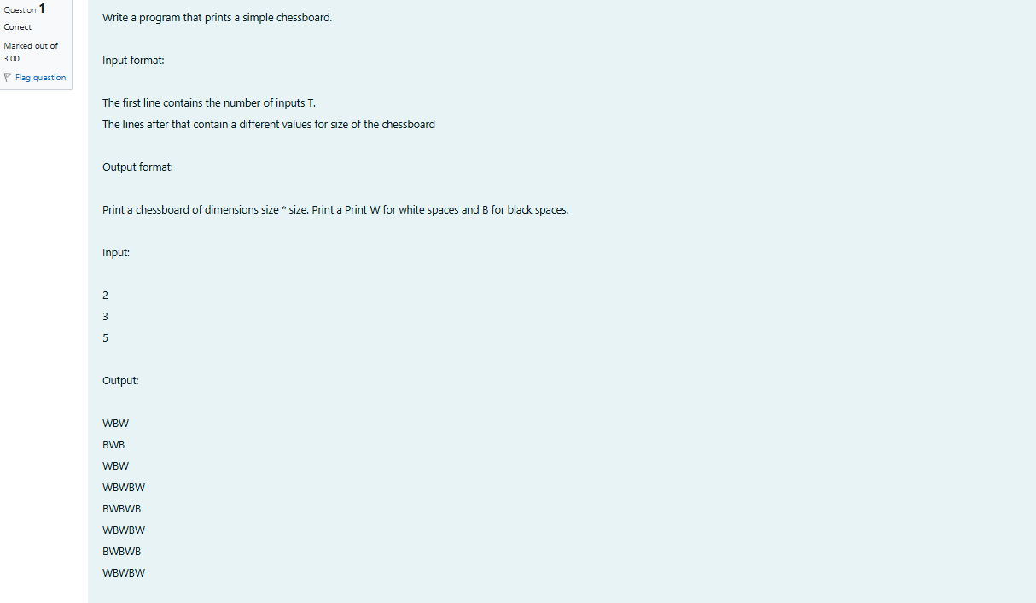

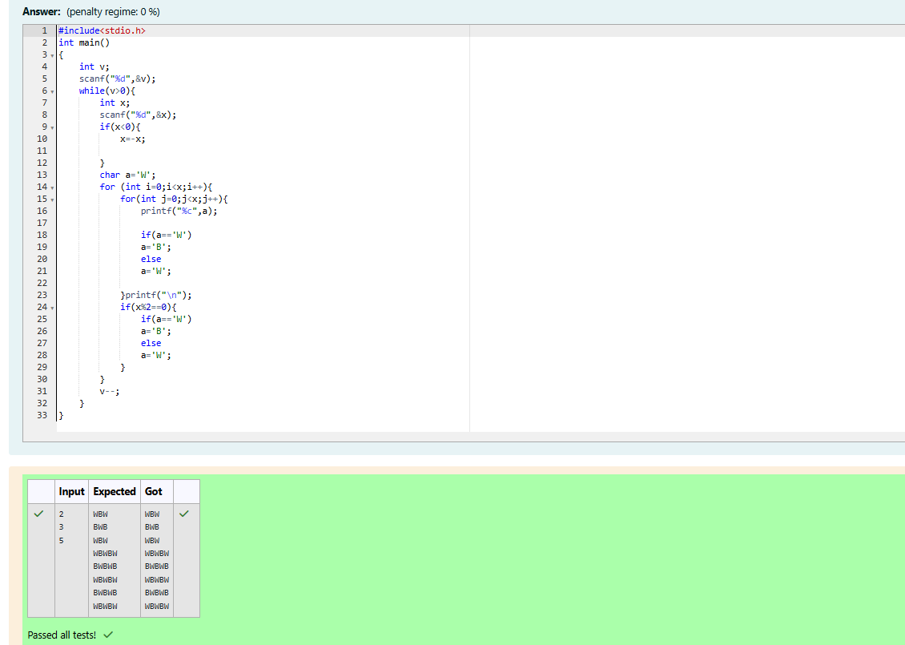

Week-05-01-practice session -coding

Reg no:24101289

Name :Tamilselvan.k

Q2

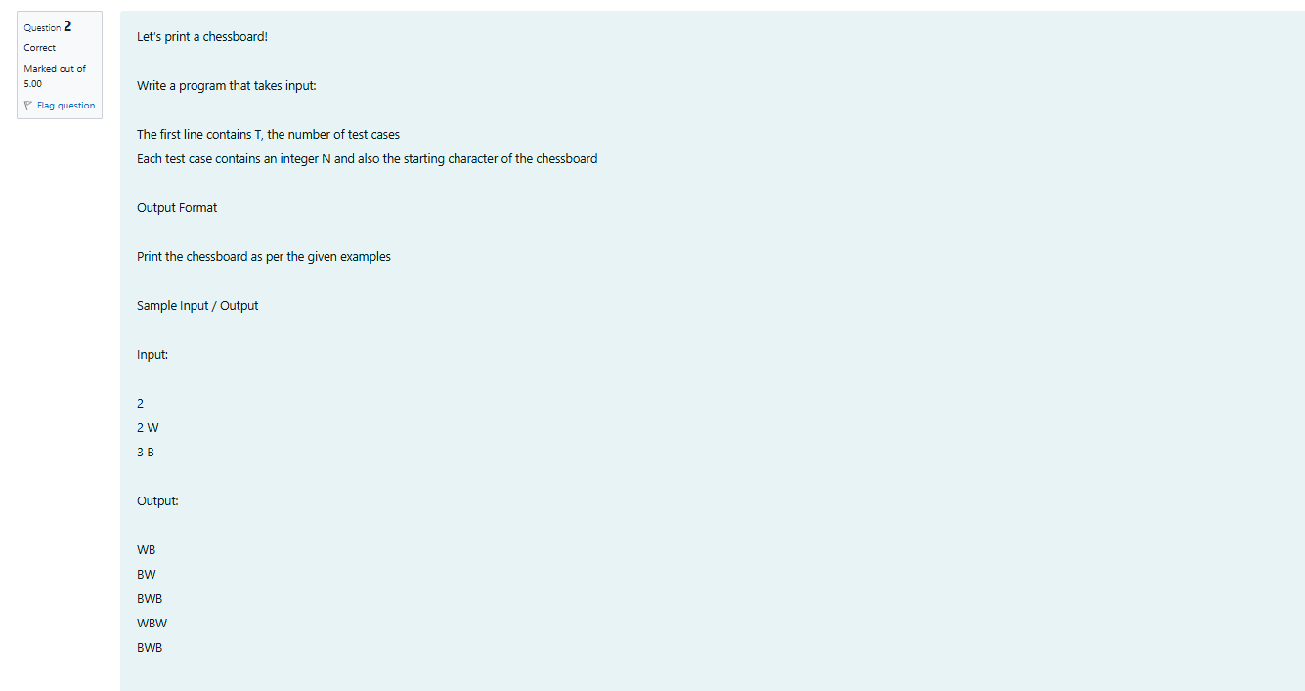

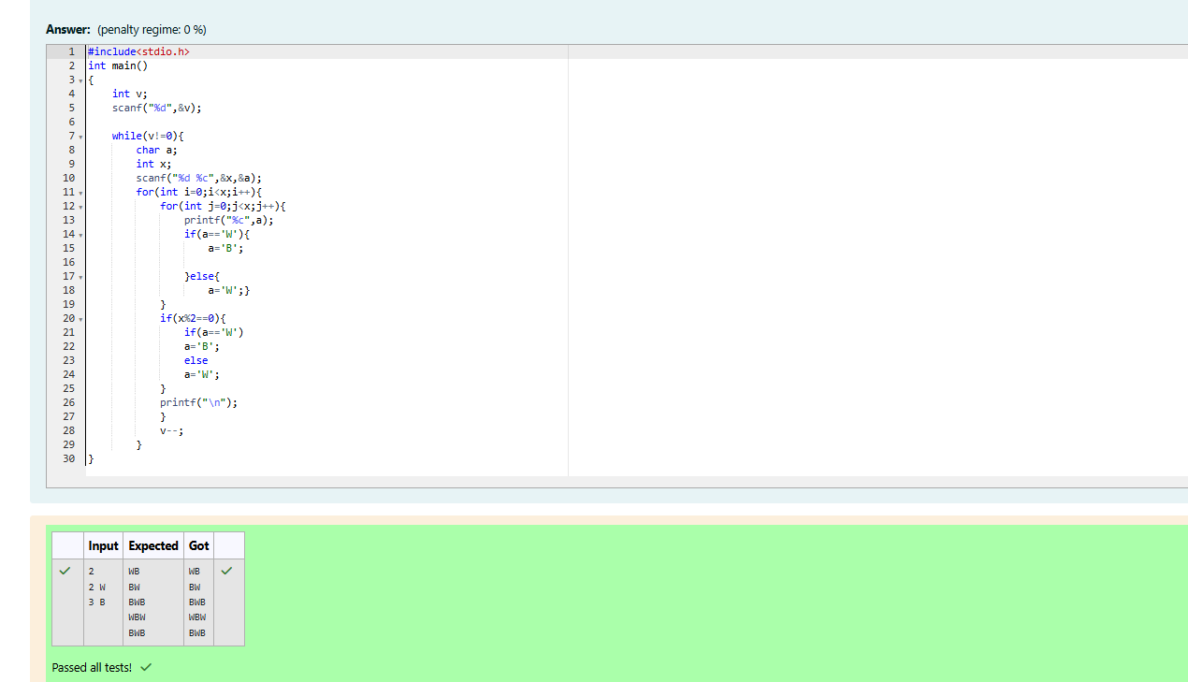

Week-05-01-practice session -coding

Reg no:24101289

Name :Tamilselvan.k

Q3

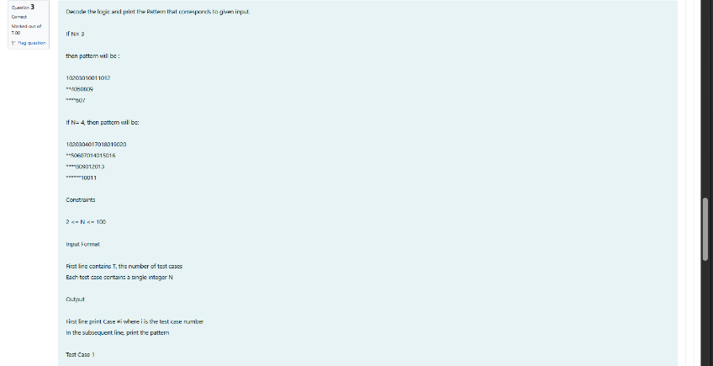

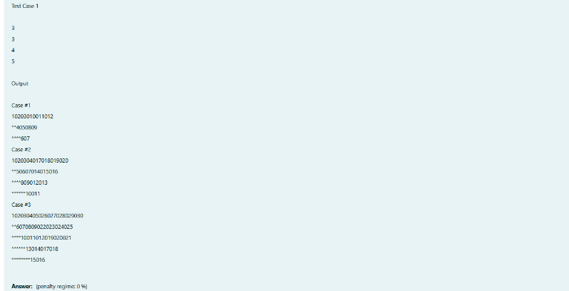

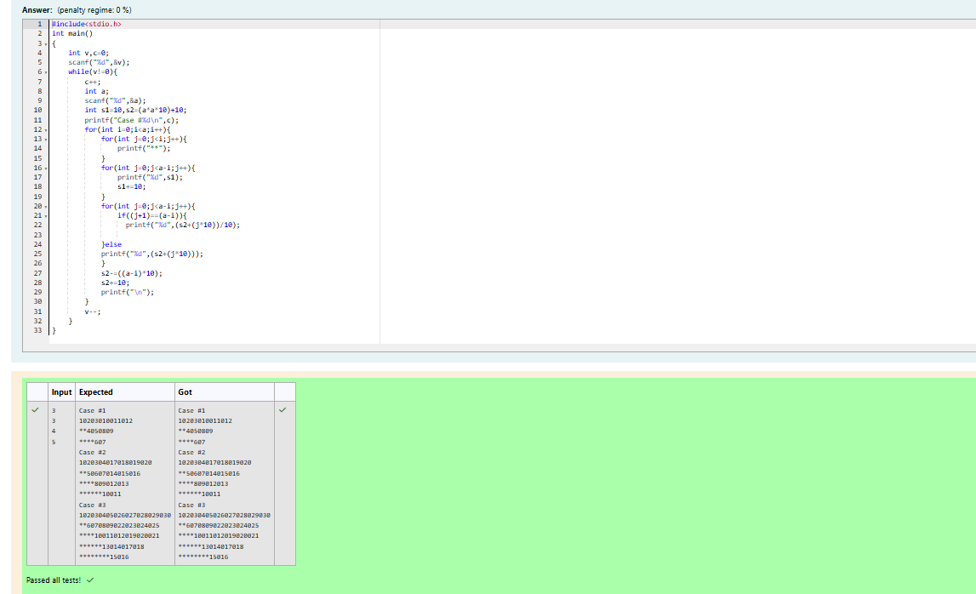

Week-05-02-practice session -coding

Reg no:24101289

Name :Tamilselvan.k

Q1





Week-05-02-practice session -coding

Reg no:24101289

Name :Tamilselvan.k

Q2

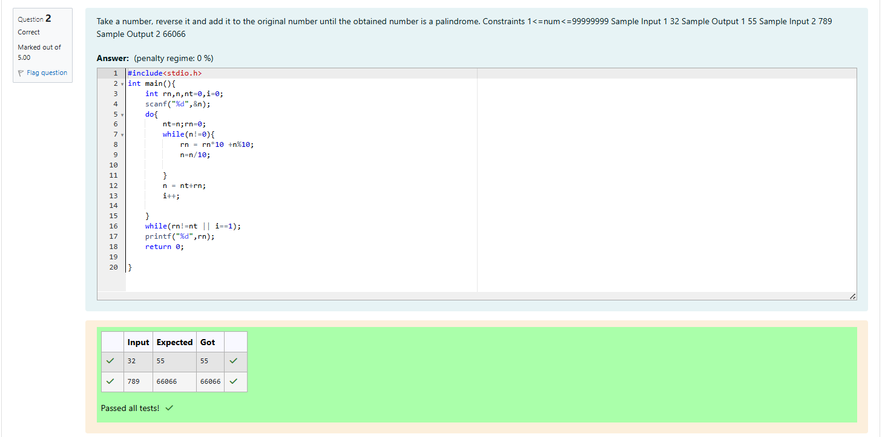

Week-05-02-practice session -coding

Reg no:24101289

Name :Tamilselvan.k

Q3

